7. Optimisation of 3D Woven Reinforcement

7.1 Introduction

as set out in the previous chapter The genetic algorithm introduced in Chapter 4 is used for the optimisation and is adapted for use in permutation optimisation.

Genetic algorithms work using a combination of evolutionary operators: crossover and mutation, to generate the next set of design candidates. For optimisation based on a bound set of integers, this will result in repeats of the design variables. For the T-Joint weaves, variation primarily occurs with the weft crossover at the junction. This means that the optimisation is based on permutations of the design variables. An adaptation is demonstrated to ensure the optimisation algorithm produced permutations by encoding the design variable integers as 4 bit strings in binary.

In this optimisation problem, there are 10 wefts which can be arranged in any order, giving (10! =) 3.6 million possible permutations. The development of a tool for the fast creation of T-joint geometry models means that the limitation of manual model generation has been eliminated. This can provide a step-change in the optimisation of weaves of these types. The optimised textile reinforcement is compared to the naïve first guess for a woven T-joint based on orthogonal weaves. Failure of the elements is shown to propagate within the expected junction zone where the stresses are highest.

7.2 Optimisation Problem

The optimisation problem is to maximise the initial tensile pull-off load which causes failure in the T-joint, subject to Hashin’s failure criteria in the yarns and the modified pressure dependent criterion in the bulk matrix. The starting point is a 10 layer orthogonal weave containing a bifurcation. The design variables are the end positions of the weft yarns after the bifurcation. Each yarn can shift to any of the final end positions and all end positions must have a yarn. No end position can be occupied by more than a single yarn. The only constraint on the design variables is that they must respect this permutation only condition.

Therefore, each design is a 10 digit string. For example, for the orthogonal weave reinforcement with no weft crossover where each weft yarn’s initial and final position in the textile matches:

Each item in the string is an end position of the wefts.

Each weave is scored on its tensile load at initial failure. This is calculated post finite element analysis by iterating through the elements for every time frame using the failure criteria set out in Chapter 6.

7.3 Implementation of Binary Encoding of Design Variables

Genetic algorithms generate design variables by varying the individual design variables within bounds. This is achieved using the mutation and crossover functions that seek to mimic the biological processes by which genetic characteristics are passed from one generation to the next. In most cases, this allows the individual digits that represent design variables multiple times within the same design string as the algorithm selects each value independently while respecting any linear constraints. One example is

Where the design variable “2” repeats twice in the string. In this case where the design variables represent the height positions of the wefts in the textile after the bifurcation it is not possible to have repeats.

To prevent this in the permutation-based optimisation, the design variables were encoded as 4 bit binary strings which can hold integer values from 0 to 15. For a design permutation with 4 variables this conversion could look like.

Which in decimal is

Each of the variables are then ranked from lowest to highest and any ties broken at random. In this case, the design variables in positions 1 and 3 have the same ranking either coming second and third or third and second from lowest. For the example this would give the final design string permutation, containing the rankings, as:

However, if the tie is broken the other way, it could also result in the final design string of:

In this case the ties were broken at random using Python’s random number generator because there is no a priori knowledge to provide a beneficial method to ranking selection for this optimisation problem. The drawback to this adaptation is that the same design string can represent more than one final design permutation.

Figure 7-1 Flow chart diagram of optimisation process highlighting how the permutation operations fit within the optimisation process. Boxes in green show the binary encoding of the design variables. Trapezoids show the model generation and finite element analysis.

The design variables generated by Matlab were fed into Python functions that ranked the variables and broke any ties to generate the string of decimal numbers making up the design permutation. These were then used to generate the geometry of the T-joint weaves for the optimisation.

The genetic algorithm was limited to crossover of its design variables to produce the next generation so that the problem is reduced to a combinatorial problem. This is appropriate given that the overall design is the result of the combination of the final weft yarn positions.

7.3 Results of the Optimisation

The optimisation was run on the University of Nottingham HPC (high performing computer cluster), in parallel, using an NSGA algorithm adapted for generating permutations of the design variables as set out in section 7.3. Each model was run using 8 CPUs, with three separate MATLAB workers generating the input files and running the analysis. The optimisation converged to a solution given by the design variable string:

[9, 5, 6, 4, 7, 8, 0, 3, 2, 1]

The geometry model generated by TexGen is shown in figure 7-2. Descending from top to bottom, the weft yarn positions 9, 8, 7, 6, 5 are on the left side of the flange in the figure while descending from top to bottom on the right side are positions 0, 1, 2, 3 and 4.

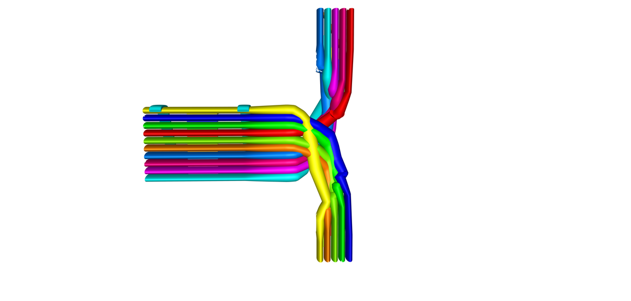

Figure 7-2 TexGen model of best performing weave reinforcement. Each half of the textile has some weft yarns that have crossed over and at least one yarn that stays in the same half of the textile.

The peak load was 1220.6N which when compared to the orthogonal weave’s peak load of 1121.7N is an 8.8% increase. The worst performing textile had a peak load of 939.0N with the best performing weave exhibiting a 30% higher peak load.

7.3.1 Comparison to Orthogonal Weave without Crossover

This section will be used to compare the difference between the optimised textile and the naïve guess of a bifurcated orthogonal textile and the worst performing textile. This will provides information about the weave characteristics in terms of the weft yarn crossover and junction shape that result in better performance in terms of the load at initial failure.

For the orthogonal textile, the weave model generated by TexGen after the application of the bifurcation transformation is shown in figure 7-3.

Figure 7-3 Orthogonal weave T-Joint reinforcement model generated using TexGen.

This model was meshed using the octree voxel mesh and run in Abaqus using the finite element tensile pull-off model and mesh parameters selected in the previous chapter. Shibo et al. [1] suggested that the best performing T-joint weaves with weft yarn variations had wefts that cross over and wefts that self entangle. The conclusions drawn in that case was based upon a limited number of model geometries. The numbers were limited because of the manual, time intensive nature of the model generation. Crossover is when weft yarns cross from one half of the textile to the other at the junction region. Entanglement was defined to be when wefts do not crossover into the other half of the textile at the bifurcation region but do crossover each other. The orthogonal weave model exhibits neither weft crossover nor entanglement. As a result, the noodle region of the model is resin rich, containing no yarns and presenting a large triangular notch shape.

The best performing textile reproduced in figure 7-4 shows four of the five yarns in the top and bottom halves of the textile respectively crossing over. There is a degree of weft entanglement from both halves with the yarns switching around. This leads to a significantly reduced notch area with a higher fibre volume fraction in this region to sustain and redistribute the stress. The model is relatively symmetric with similar entanglement and crossover from both textile halves.



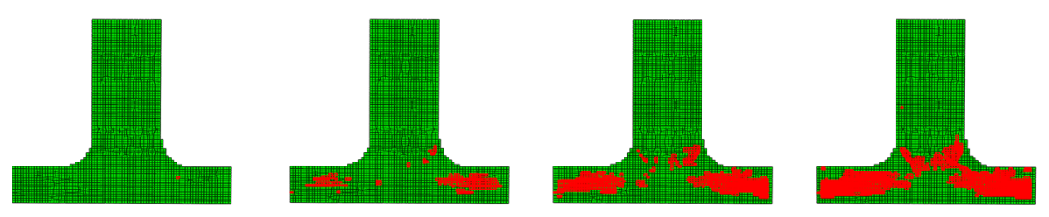

Figure 7-4 TexGen model of best performing weave reinforcement above the finite element mesh showing progression of element failure at displacements 0.1, 0.2, 0.3 and 0.4mm

For this best model, the first element failure occurs on the transition zone between the junction region and the flange. As the displacement increases, failure propagates into the junction region via the yarn the yarn that has transitioned from the second from top position (in blue in figure 7-4) to the bottom. This may be due to its relative proximity to the centre of the junction region. The number of failed yarns remains higher in the flange than in the junction region, suggesting that the stresses have been successfully distributed by the weave configuration. One possible reason for this is the greater amount of fibre along the loading direction caused by weft crossover.

The worst performing textile is shown in figure 7-5

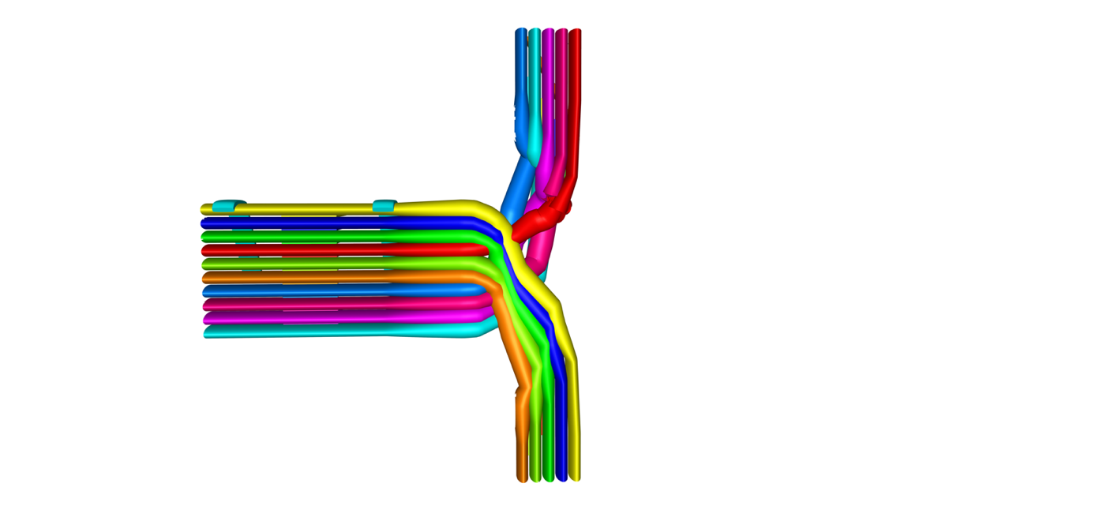

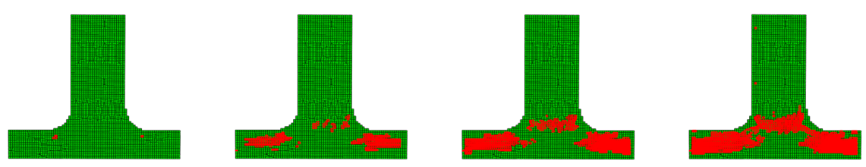

Figure 7-5 TexGen model of worst performing weave reinforcement. Entanglement occurs in the right half of the textile but there is no entanglement in the left half. This leaves some resin richness in the noodle.

The worst performing textile similarly had a high degree of weft crossover with 4 out of 5 wefts again moving to the other half of the textile. However, the textile is highly asymmetric with almost no entanglement in the yarns crossing over from the top half of the textile to the bottom half so they remain to a greater degree transverse to the loading axis. In addition, this leaves some resin richness in the noodle. It can be seen that the first elements again fail in the transition zones between junction and flange. It is difficult to ascertain the proportion of elements failing in the junction for each model because this zone is not well defined, however, by the 0.2 mm displacement visually a greater proportion of the elements have failed in the junction compared to the best performing textile. In figure 7-6 it can be seen that there are more failed elements in the junction region for the worst performing T-joint.

For the models below the elements failed at 0.1, 0.2, 0.3 and 0.4mm of displacement are shown, with the straight yarn model at the top followed by the worst model in the optimisation and then the best. It can be seen that yarn element failure for the straight and worst models concentrates to a greater degree in the junction region of the T-Joint. A lower number of yarn elements in the junction region, created from the configuration of the weft yarns, is a probable reason for this.

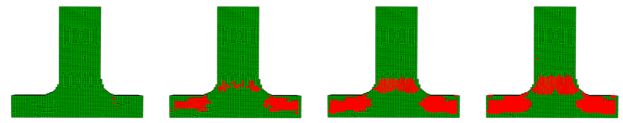

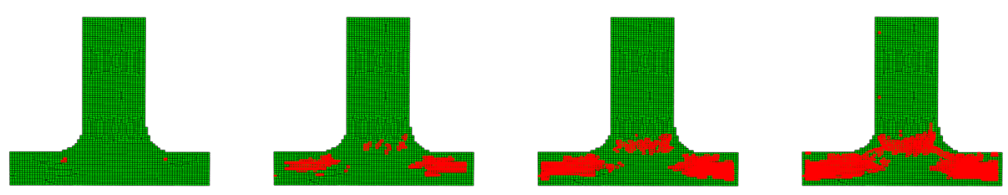

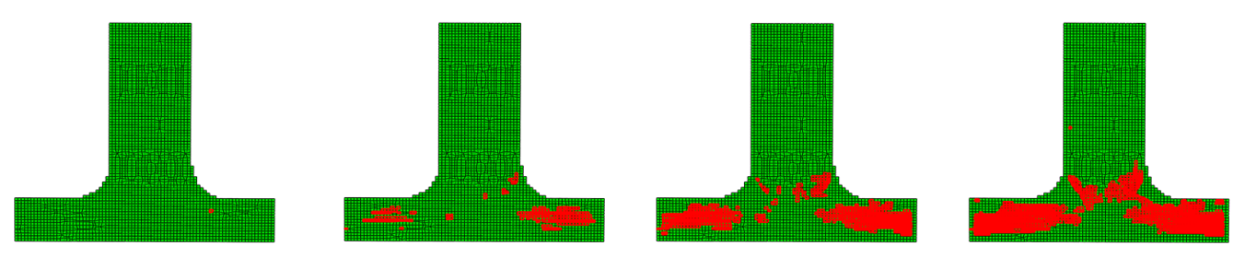

Figure 7-6 From top-to-bottom finite element models, straight weave with no weft crossover, the worst performing textile and the best performing. Each model has the failed elements at displacements 0.1, 0.2, 0.3 and 0.4mm respectively.

Determining the exact point of failure when initial failure can be said to have occurred discussed in Chapter 6. The numbers of elements failed plotted against the increment time are shown in figure 7-7. The measure of initial failure was set to 2% of the global element number. For the straight model, the models at different displacements are overlaid on the number of element graph shown.

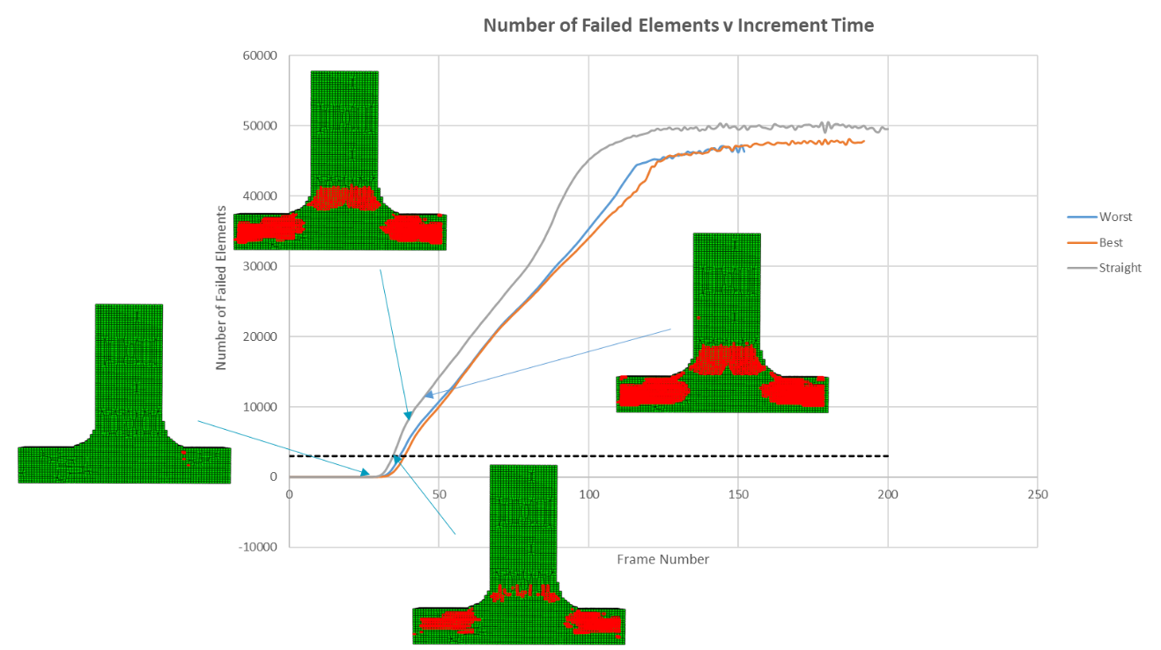

Figure 7-7 Graph of number of failed elements against increment time. The locations of element failure for the orthogonal (straight) graph are shown at 0.1, 0.2, 0.3 and 0.4mm. The horizontal dashed line shows the approximate 2% of element number line.

The graphs plotted above were created by querying the stresses in the results file at every frame which causes the number of failed elements fluctuates near the top end, reflecting the oscillations in the force-displacement behaviour which appear due to the use of the explicit solver.

The number of failed elements reaches the 2% initial failure threshold for the straight T-Joint model at 0.2mm. The graphs for the best and worst models are in figure 7-7. The best model has a displacement of 0.26mm at initial failure while the worst model has a displacement of 0.24mm.

Figure 7-8 Number of Failed Elements against applied Displacement for Best and Worst performing models.

7.5 Conclusions

Optimisation of T-joint weave reinforcement under tensile pull-off load has been carried out using binary encoding of design variables to allow optimisation based on the permutations of weft yarn variations using a genetic algorithm on an HPC.

The optimum textile showed an 8.8% increase in the load at initial failure when compared to the orthogonal weave with no crossover of the weft yarn and a 30% increase over the worst performing weave.

The optimum textile found had a reduced noodle region, achieved by a combination of weft yarn crossover and entanglement. Four yarns of the five in each half crossover while one remains in the same half. This arrangement allows the noodle to be flattened out and stresses redistributed so that the failure occurs further away from the noodle region. The crossover and entanglement allows there to be more fibre placed along the direction of the loading within the junction region. This can be contrasted with the worst performing weave reinforcement and the orthogonal (straight) weave which both had reduced levels of weave entanglement resulting in a greater proportion of the yarns aligned transverse to the loading direction.